Products Sidebar filters (vertical filter)
- show all filters checked by default(database/products/brand)
- Show all category by default.(database/products/category)
- batch filtering by clicking “Show result”
It is also helpful for user to know number of results within the button like “Show 12 results” before page reloads.
- show loading box whenever filter is applied.
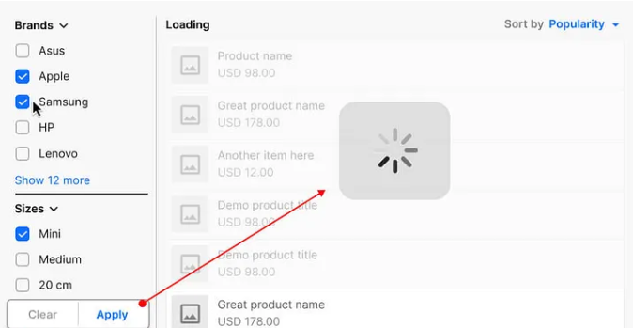

Above example shows there is “Search” input and “Reset” button after filter checked.
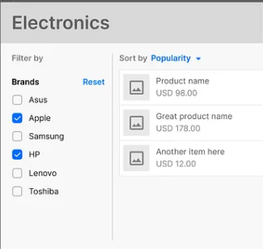
It is recommended not to show entire list of available filter options (checkboxes or links). Show only 3-4 most important checkboxes/links and hide others under the “Show more” expandable button.

- Let user know how many items in total available based on that filter.
(For ex: 10 items found)
- Let user clear all filter with single click “Clear all button”
- Show user which filters has been applied. User may forget that he/she is applied some filters from sidebar and that filter is hidden under “show more” link. There is a UI element called “chip”. We will show applied filter as “chip” at the top. “Chip”s can be removed individually.
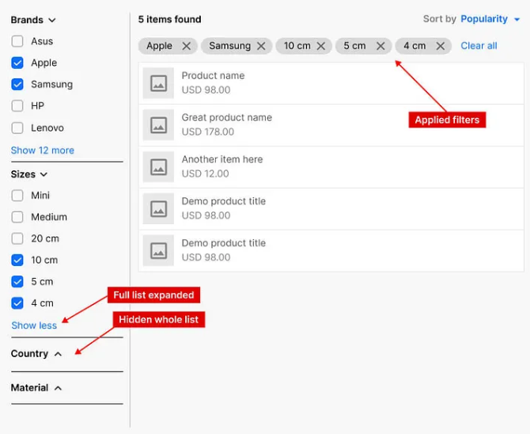
One more thing to keep in mind about showing applied filter:
Let’s imagine, some filter criteria are similar, For ex: Filter by: “Seat numbers” and “Number of wheels”. So, both are numbers. Another example: Filter by “Manufactured country” and filter by “Shipping to country”. Both lists are similar. In that case it is important to show the title of applied filter on every removable “chip”. Here is example:
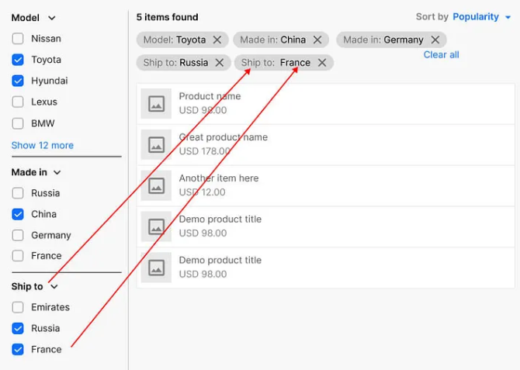
Filter by price
- Typing manually
